CO5 – Pandas & Matplotlib Visualization Projects
Hospital Patient Analysis Dashboard & Stock Market Pattern Analysis Dashboard

4. Hospital Patient Analysis Dashboard
Objective: Build a dashboard using patient data containing age, blood pressure, cholesterol, BMI, treatment cost, and admission date. The dashboard presents distributions, counts, relationships, time-based admission trends, lag plots, and autocorrelation to identify recurring admission patterns.

Dataset Columns
- Age – age of the patient in years
- BloodPressure – recorded blood pressure value
- Cholesterol – cholesterol level
- BMI – body mass index
- TreatmentCost – treatment cost
- AdmissionDate – date of hospital admission

Python Code
import pandas as pd
import matplotlib.pyplot as plt
# Upload dataset
from google.colab import files
uploaded = files.upload()
# Read dataset
df = pd.read_csv("hospital_patients.csv")
# Convert date column
df["AdmissionDate"] = pd.to_datetime(df["AdmissionDate"])
# Display dataset
print("Hospital Patient Dataset")
print(df.head())
# -------------------------------
# Visualizations
# -------------------------------
plt.figure(figsize=(12, 8))
# Age distribution
plt.subplot(2, 3, 1)
plt.hist(df["Age"], bins=10, edgecolor="black")
plt.title("Age Distribution")
plt.xlabel("Age")

# Blood pressure distribution
plt.subplot(2, 3, 2)
plt.hist(df["BloodPressure"], bins=10, edgecolor="black")
plt.title("Blood Pressure")
plt.xlabel("Blood Pressure")
# BMI distribution
plt.subplot(2, 3, 3)
plt.hist(df["BMI"], bins=10, edgecolor="black")
plt.title("BMI Distribution")
plt.xlabel("BMI")
# Age vs Treatment Cost
plt.subplot(2, 3, 4)
plt.scatter(df["Age"], df["TreatmentCost"])
plt.title("Age vs Treatment Cost")
plt.xlabel("Age")
plt.ylabel("Treatment Cost")
# Admissions over time
daily = df.groupby("AdmissionDate").size()
plt.subplot(2, 3, 5)
plt.plot(daily)
plt.title("Admissions Over Time")
plt.xlabel("Date")
plt.ylabel("Admissions")
# Monthly admissions
monthly = df.groupby(
df["AdmissionDate"].dt.to_period("M")
).size()
plt.subplot(2, 3, 6)
plt.plot(monthly.index.astype(str), monthly)
plt.title("Monthly Admissions")
plt.xticks(rotation=45)
plt.tight_layout()
plt.show()
# -------------------------------
# Lag Plot
# -------------------------------
pd.plotting.lag_plot(daily)
plt.title("Lag Plot of Hospital Admissions")
plt.show()
# -------------------------------
# Autocorrelation Plot
# -------------------------------
pd.plotting.autocorrelation_plot(daily)
plt.title("Autocorrelation of Hospital Admissions")
plt.show()

Output Screenshot – Main Dashboard
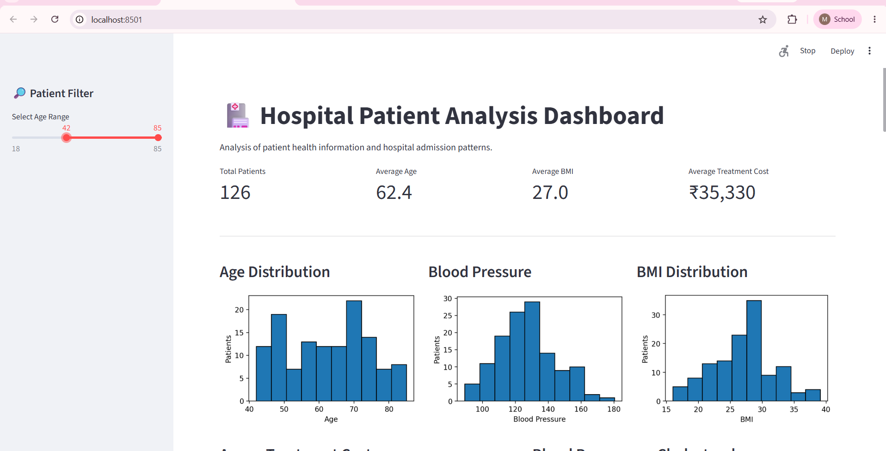

Output Screenshot – Lag and Autocorrelation
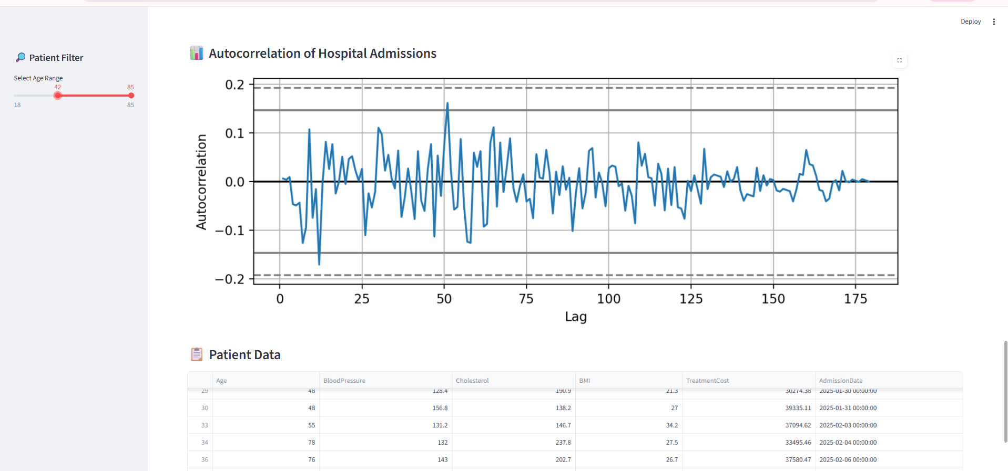

Result
The dashboard visualizes patient characteristics and their relationships. The time-series plots show admission activity over time, while the lag plot and autocorrelation plot help identify whether admissions on one day are related to admissions on nearby days.

5. Stock Market Pattern Analysis Dashboard
Objective: Develop a dashboard using historical stock data containing date, opening price, closing price, high, low, and trading volume. The dashboard visualizes price evolution, distributions, price-volume relationships, lag behavior, autocorrelation, and bootstrap-based uncertainty.

Dataset Columns
- Date – trading date
- Open – opening price
- Close – closing price
- High – highest price during the trading session
- Low – lowest price during the trading session
- Volume – number of shares/units traded

Python Code
import pandas as pd
import matplotlib.pyplot as plt
import numpy as np
# Upload dataset
from google.colab import files
uploaded = files.upload()
# Read dataset
df = pd.read_csv("stock_data.csv")
# Convert date column
df["Date"] = pd.to_datetime(df["Date"])
# Display dataset
print("Stock Market Dataset")
print(df.head())
# -------------------------------
# Visualizations
# -------------------------------

plt.figure(figsize=(12, 8))
# Closing price evolution
plt.subplot(2, 3, 1)
plt.plot(df["Date"], df["Close"])
plt.title("Closing Price Evolution")
plt.xticks(rotation=45)
# Price distribution
plt.subplot(2, 3, 2)
plt.hist(df["Close"], bins=10, edgecolor="black")
plt.title("Closing Price Distribution")
# Volume distribution
plt.subplot(2, 3, 3)
plt.hist(df["Volume"], bins=10, edgecolor="black")
plt.title("Trading Volume Distribution")
# Price vs Volume
plt.subplot(2, 3, 4)
plt.scatter(df["Close"], df["Volume"])
plt.title("Price vs Volume")
plt.xlabel("Closing Price")
plt.ylabel("Volume")
# High vs Low
plt.subplot(2, 3, 5)
plt.scatter(df["High"], df["Low"])
plt.title("High vs Low")
plt.xlabel("High")
plt.ylabel("Low"
# Daily returns
df["Return"] = df["Close"].pct_change()

plt.subplot(2, 3, 6)
plt.hist(df["Return"].dropna(), bins=10, edgecolor="black")
plt.title("Daily Return Distribution")
plt.tight_layout()
plt.show()
# -------------------------------
# Lag Plot
# -------------------------------
returns = df["Return"].dropna()
pd.plotting.lag_plot(returns)
plt.title("Lag Plot of Stock Returns")
plt.show()
# -------------------------------
# Autocorrelation Plot
# -------------------------------
pd.plotting.autocorrelation_plot(returns)
plt.title("Autocorrelation of Stock Returns")
plt.show()
# -------------------------------
# Bootstrap Plot
# ------------------------------
bootstrap = []
for i in range(500):
sample = np.random.choice(
returns,
size=len(returns),
replace=True
)
bootstrap.append(sample.mean()
plt.hist(bootstrap, bins=15, edgecolor="black")
plt.title("Bootstrap Distribution of Mean Return")
plt.xlabel("Mean Return")
plt.ylabel("Frequency")
plt.show()

Output Screenshot – Main Dashboard
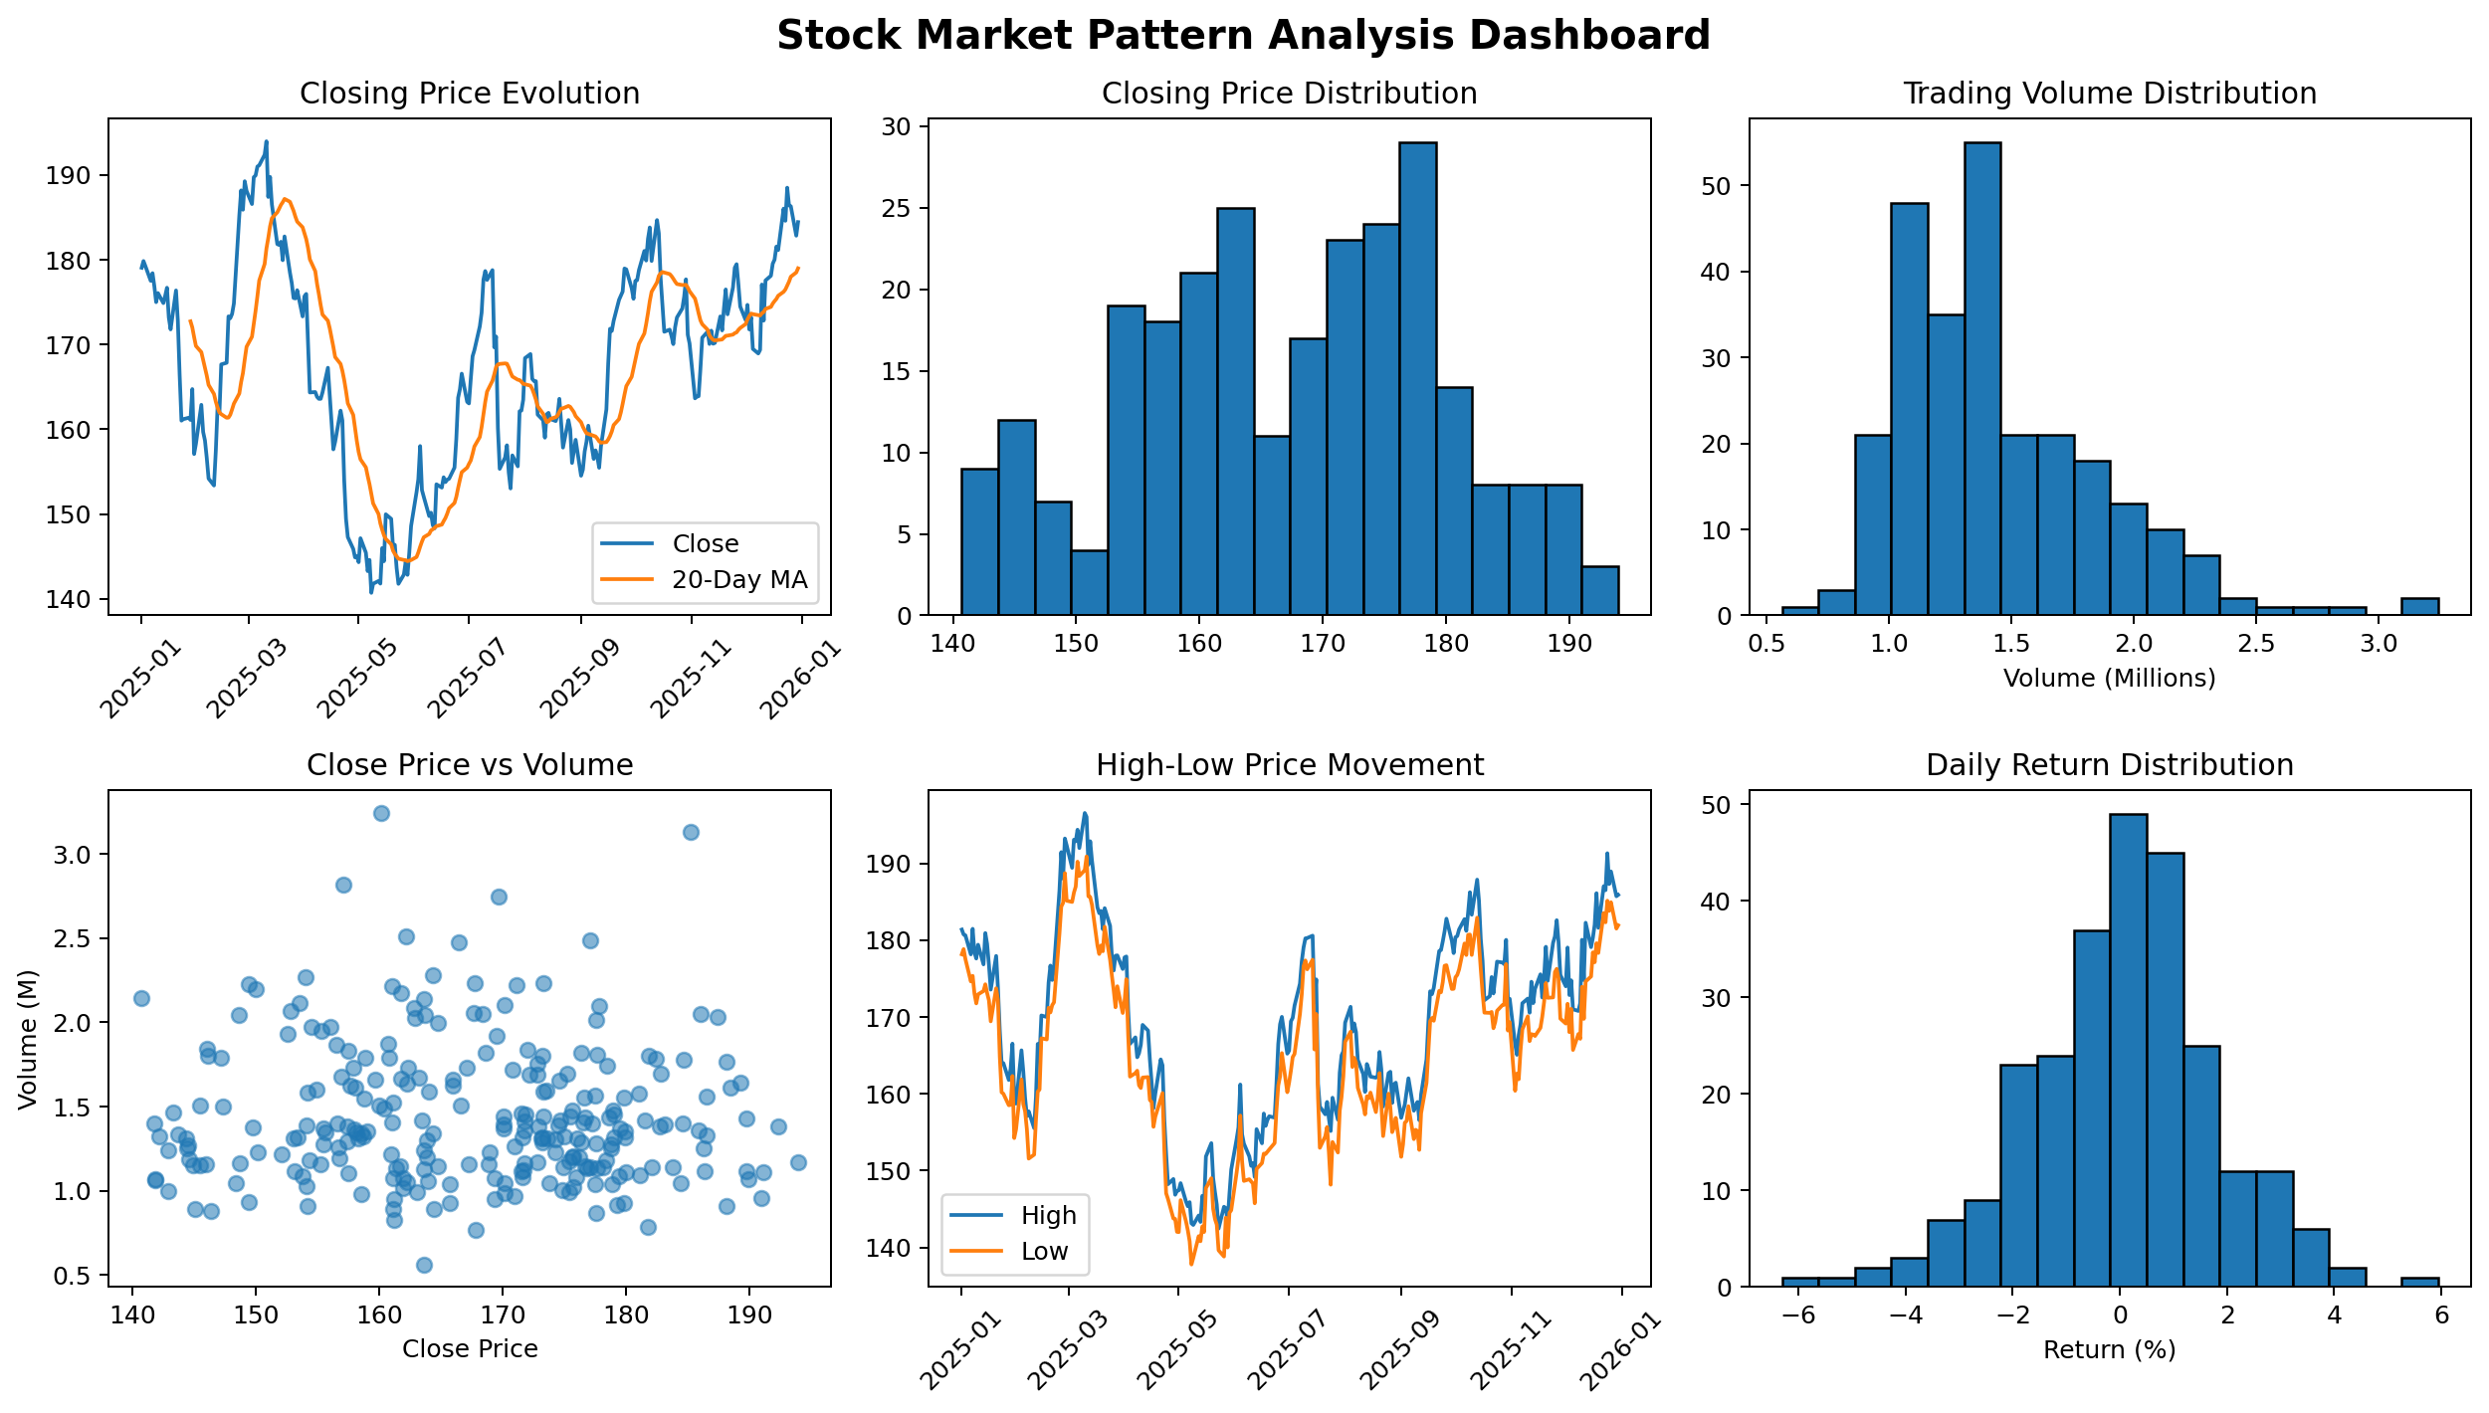

Output Screenshot – Lag, Autocorrelation and Bootstrap
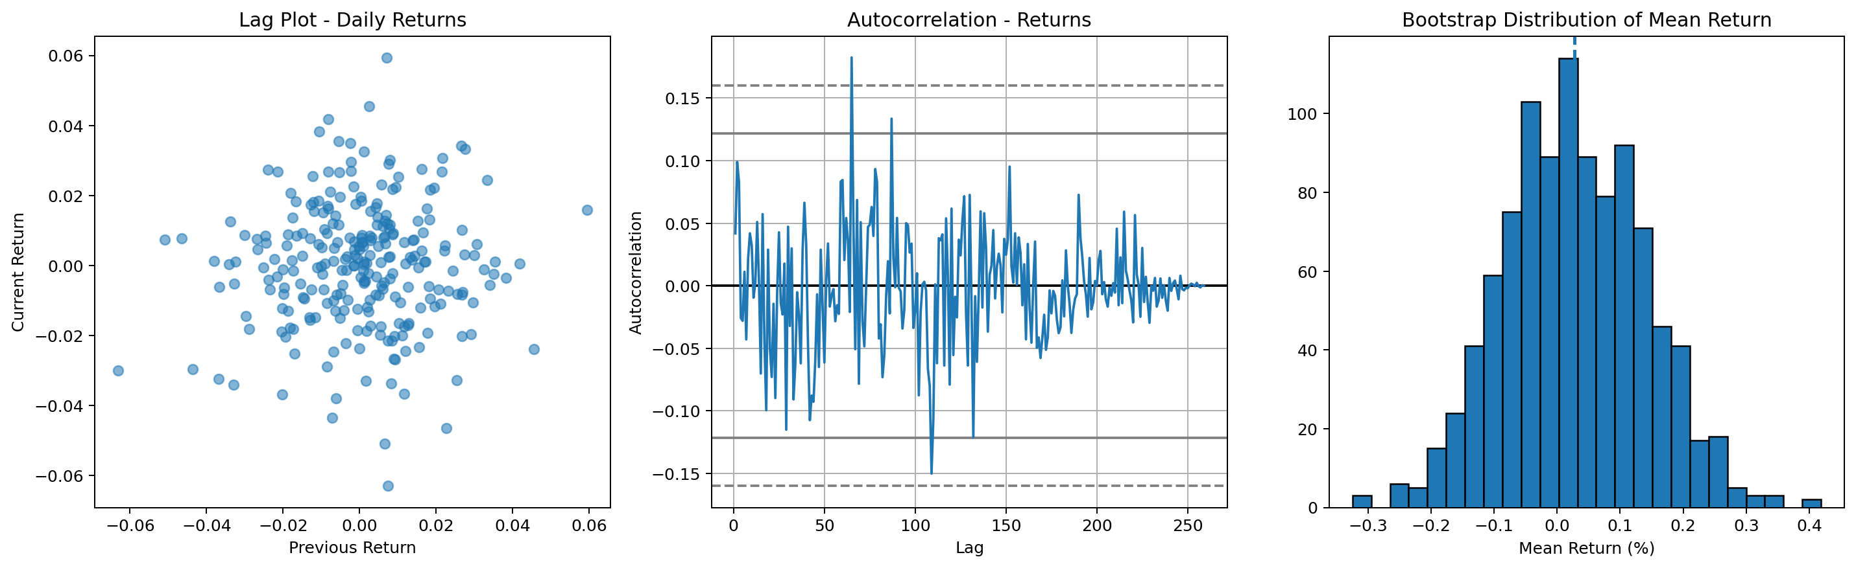

Result
The stock dashboard shows price movement and trading-volume behavior. The lag and autocorrelation plots help examine dependencies in daily returns. The bootstrap distribution provides an empirical view of uncertainty in the estimated mean return.

Conclusion
Both dashboards demonstrate the CO5 outcome of creating meaningful visualizations with Pandas and Matplotlib. The hospital dashboard focuses on healthcare distributions, relationships, and admission patterns, while the stock dashboard focuses on time-series behavior, price-volume relationships, dependencies, and uncertainty.

